**“CAFE BILLING SYSTEM”**

**Mini Project Report 1-B**

Submitted in partial fulfillment of the requirements for

**Second year of Engineering (Computer Engineering)**

**By**

Karishma Apparao Bairi TU3F1920014

Ketki Milind Kulkarni TU3F1920053

Shweta Madhukar Kaware TU3F1920005

Aman Lakhotra TU3F1920020

Under the Guidance of

**Dr. Siddharth Hariharan**



**Department of Computer Engineering TERNA ENGINEERING COLLEGE**

Nerul (W), Navi Mumbai 400706

(University of Mumbai)

(2020-2021)

**Internal Approval Sheet**



**TERNA ENGINEERING COLLEGE, NERUL**

**Department of Computer Engineering**

Academic Year 2020-21

**CERTIFICATE**

This is to certify that the project entitled **“CAFE BILLING SYSTEM”** is a bonafide work of

Karishma Apparao Bairi TU3F1920014

Ketki Milind Kulkarni TU3F1920053

Shweta Madhukar Kaware TU3F1920005

Aman Lakhotra TU3F1920020

submitted to the University of Mumbai in partial fulfilment of the requirement

for the Second year of Engineering. (Computer Engineering).

**Guide Project Convener Head of Department Principal**

**Approval Sheet**

Project Report Approval

This Project Report – A entitled **“CAFE BILLING SYSTEM”** by following students is approved for S.E. in "Computer Engineering".

***Submitted by:***

Karishma Apparao Bairi TU3F1920014

Ketki Milind Kulkarni TU3F1920053

Shweta Madhukar Kaware TU3F1920005

Aman Lakhotra TU3F1920020

Examiner’s Name & Signature:

1. ______________________
2. ______________________

Date:

Place:

**DECLARATION**

We declare that this written submission represents our proposal in our own words and where others ideas or words have not been included, we have suitably mentioned and referenced the original sources. We also declare that we have stuck to all principles of academic uprightness and integrity and have not misrepresented or created or falsified any idea/data/fact/source in our submission. We understand that any infraction of the above will be cause for disciplinary action by the Institute and can also call up penal action from the sources which have thus not been properly mentioned or from whom proper permission has not been taken when needed.

Karishma Apparao Bairi TU3F1920014 ---------------------------

Ketki Milind Kulkarni TU3F1920053 ---------------------------

Shweta Madhukar Kaware TU3F1920005 ---------------------------

Aman Lakhotra TU3F1920020 ---------------------------

Date:

Place:

**ACKNOWLEDGEMENT**

Project is never complete without the guidance of those expert who have already traded this past before, and hence become master of it and as a result, our leader. So, we would like to take this opportunity to take all those individuals who have helped us in visualizing this project.

We express our extensive gratitude to our project guide Dr.Siddharth Hariharan for providing timely assistant to our query and guidance that he gave owing to his experience in this field for past many years. He had indeed been a leading light for us in this journey.

We would also take this opportunity to thank our project coordinator Mrs. Ujwala Gaikwad for her guidance in selecting this project and also for providing us all this details on proper presentation of this project.

We extend our sincere appreciation to all our Professor from TERNA ENGINEERING COLLEGE for their valuable insight and tip during the designing of the project. Their contributions have been valuable in so many ways that we find it is difficult to acknowledge them individually.

We are also obliged to our HOD Mrs. Archana Mire for extending her help directly and indirectly through various channel in our project work.

We take the privilege to express our sincere thanks to Principal Dr. L. K. Ragha for providing encouragement and much support throughout our work.

Karishma Apparao Bairi TU3F1920014

Ketki Milind Kulkarni TU3F1920053

Shweta Madhukar Kaware TU3F1920005

Aman Lakhotra TU3F1920020

**Table of contents**

ABSTRACT…………………………………………………………………………………...7

CHAPTER 1: INTRODUCTION…………………………………………………………….8

1.1 AIM AND OBJECTIVE OF THE PROJECT…………………………………………...9

1.2 SCOPE OF THE PROJECT……………………………………………………………...9

1.3 ORGANIZATION OF THE REPORT…………………………………………………10

CHAPTER 2: LITERATURE REVIEW…………………………………………………...11

2.1 EXPLANATION OF THE LITERATURE PAPERS………………………………….12

CHAPTER 3: METHODOLOGY…………………………………………………………..13

3.1 BLOCK DIAGRAM……………………………………………..................................14

3.2 EXPLANATION OF THE BLOCK DIAGRAM……………………………………..15

3.3 MODULES OF SYSTEM…………………………………………………………….15

3.4 SYSTEM DESIGN……………………………………………………………………16

CHAPTER 4: HARDWARE & SOFTWARE REQUIREMENTS………………………...21

CHAPTER 5: IMPLEMENTATION……………………………………………………….24

5.1: OVERVIEW OF RESULTS……………………………………………………........24

5.2: CODE…....…………………………………………………………………………...24

5.3: EXPLANATION OF CODE ………………………………………………………...30

CHAPTER 6: RESULTS AND DISCUSSION…………………………………………….31

CHAPTER 7: CONCLUSION……………………………………………………………...39

REFERENCES……………………………………………………………………………....40

**ABSTRACT**

The purpose of Cafe Billing System is to automate the existing manual system by the help of computerized equipments and full-fledged computer software, fulfilling their requirements, so that their valuable data/information can be stored for a longer period with easy accessing and manipulation of the same. The required software and hardware are easily available and easy to work with.

Cafe Billing System, as described above, can lead to error free, secure, reliable and fast management system. It can assist the user to concentrate on their other activities rather to concentrate on the record keeping. Thus it will help organization in better utilization of resources. The organization can maintain computerized records without redundant entries. That means that one need not be distracted by information that is not relevant, while being able to reach the information.

**CHAPTER 1: INTRODUCTION**

Cafe Billing System, as described above, can lead to error free, secure, reliable and fast management system. It can assist the user to concentrate on their other activities rather to concentrate on the record keeping. The organization can maintain computerized records without redundant entries.

This system is named as Cafe billing system. This is designed especially for a Cafe which wants to attend their customers in a very well manner. This system has the capability to take the orders from the customers.

This project sets to design, build and test a web-based computerized cafe system. One of the driving forces behind the innovation of such a system is the attempt to replace the error prone and monotonous paper-based system. Commonly, the workflow of the system would start from waiters gathering orders from the customer on an order sheet, then passing this to kitchen chefs for meal preparation and finally collecting payment from the customer. This process can promote certain risks however, especially during peak period, they are not limited to the loss of order sheet, incorrect sequence of meal preparation, and added cost due to mistaken orders. Eventually, they may lead to low productivity and customer dissatisfaction. Realizing these problems can affect business performance, so the cafe owner quickly seeks a remedy by adopting IT into their business model.

IT has become important tools to support business operations. Especially in the cafe business, IT is playing increasingly important roles in resources administration, managing services, and assisting strategic decision making. Several analysis and research works have also suggested that competitive use of IT in a cafe has significant advantages. In terms of operational benefits, it can improve process efficiency, reduce possible human errors, and maximize use of resources. Additionally, it also supports long term business goals, including achieving cost-effectiveness, maximizing profits, and the potential to penetrate wider markets.

Customer can opt for his/her choice of payment. This system has the capability of calculating the bill according to the total number of the items ordered and taxes are also added accordingly, then shown to the customer in a proper bill.

Further, we will see the designing of the system and parameters of it on the basis of which our system does work properly.

**1.1: AIM AND OBJECTIVE OF THE PROJECT**

The main objective of the Cafe Billing System is to manage the details of Bills, Payment, Customer, Payment Mode, Delivery. It manages all the information about Customer, Customer Payment Mode, Calculation of bill. The project is totally built at an administrative end and thus only the administrator is guaranteed the access. The purpose of the project is to build an application program to reduce the manual work for managing the Bills, Payment, Cash, Customer. It tracks all the details about the Customer, Payment Mode, Calculation of taxes.

**1.2: SCOPE OF THE PROJECT**

This billing system focus on the development of an information system that will automate manual transaction in Beatriz Food and Cafe.

It will generate receipt on every transaction inputted to the system.

The software will display view of calculations of every transaction.

The system will store and recognize customer reservations.

**1.3: ORGANIZATION OF THE REPORT**

Chapter 1 contains brief introduction of our project with aim, objective and scope of the project.

Chapter 2 contains Literature Survey. In this chapter, we have studied and reviewed the previous work done on the topics related to our project. We have included different papers published by their respective authors.

Chapter 3 Methodology deals with the Block Diagram, Explanation of the Block Diagram, Modules of System and System Design Details.

Chapter 4 includes Hardware and Software Requirements of the project.

Chapter 5 includes the code of the project.

Chapter 6 contains screenshots of the output.

Chapter 7 is the conclusion of the project.

Lasly, it has list of references.

**CHAPTER 2: LITERATURE REVIEW**

**Table 2.1: Literature Review**

|  |  |  |  |
| --- | --- | --- | --- |
| **Year** | **Author Name** | **Paper Name** | **Description** |
| 2019 | Wong Siew Jiuan | <http://eprints.utar.edu.my/3448/1/fyp_IA_2019_WSJ_1506513.pdf> | The strength of this system is that the time has been reduced during billing. . Especially during the peak hours the customers do not need to wait for long time .The weakness of this system is it does not support real-time tax calculation. The customers are unable to see the percentage of tax included. |
| 2017 | Shraddha G. Malviya | <https://www.ijser.org/researchpaper/A-Review-Paper-on-Smart-Restaurant-Ordering-System.pdf> | This system enhances the experience and save their time during billing. This project aims to save the time during billing process in cafe as well as to improve the dining experience of customers. |
| 2015 | Prof. N.M Yawale | <http://www.iaetsdjaras.org/gallery/14-jaras-327-december.pdf> | The system is implemented to reduce the manual work and enhances the accuracy of work in a cafe. This system manages and maintains the record of customers and their order. The billing system prepares the bill according to the food. This system entirely reduces the unnecessary time. The cost can be calculated in real time. |
| 2013 | Ashwani Banker | <https://www.irjet.net/archives/V7/i4/IRJET-V7I41009.pdf> | This Cafe Billing system was developed in order to save their time during billing.The online survey showed that most people were satisfied with this biiling system. |
| 2010 | Sakari Pieska | <https://www.iosrjournals.org/iosr-jeee/Papers/Vol10-issue3/Version-1/A010310105.pdf> | This billing system was used to enhance the accuracy of work. It was used to generate bills without any discrepancies by saving customers information. |

**2.2: EXPLANATION OF LITERATURE PAPERS**

**Paper 1: By Wong Sieu Jiuan**

The strength of this system is that the time has been reduced during billing. . Especially during the peak hours the customers do not need to wait for long time .The weakness of this system is it does not support real-time tax calculation. The customers are unable to see the percentage of tax included.

**Paper 2: By Prof. N.M Yamale**

The system is implemented to reduce the manual work and enhances the accuracy of work in a cafe. This system manages and maintains the record of customers and their order . This cafe billing system prepares the bill according to the food. This system entirely reduces the unnecessary time. The cost can be calculated in real time.

**Paper 3: By Shraddha G.Malviya**

This system enhances the experience and save their time during billing . This project aims to save the time during billing process in cafe as well as to improve the dining experience of customers.

**Paper 4: By Ashwani Banker**

This Cafe Billing system was developed in order to save their time during billing.The online survey showed that most people were satisfied with this biiling system.

**Paper 5: By Sakari Pieska**

This billing system was used to enhance the accuracy of work. It was used to generate bills without any discrepancies by saving customers information.

**CHAPTER 3: METHODOLOGY**

This system is names as Cafe billing system. This is designed especially for a cafe which wants to attend their customers in a very well manner.This system has the capability to take the orders from the customers. It generates unique transaction id for billing according to the selection of the mode of payment.

The great thing is that it will be simply utilized by the staffs of various departments and is powered with extremely customisable strong options to fulfill each demand of your customer, be it managing the stocks/inventory, increasing business potency, increasing table turn around, managing totally different branches, aggregation client feedback, or managing any knowledge that’s necessary for your customer, no matter the placement and time, we have got it all covered.

**3.1: BLOCK DIAGRAM:**

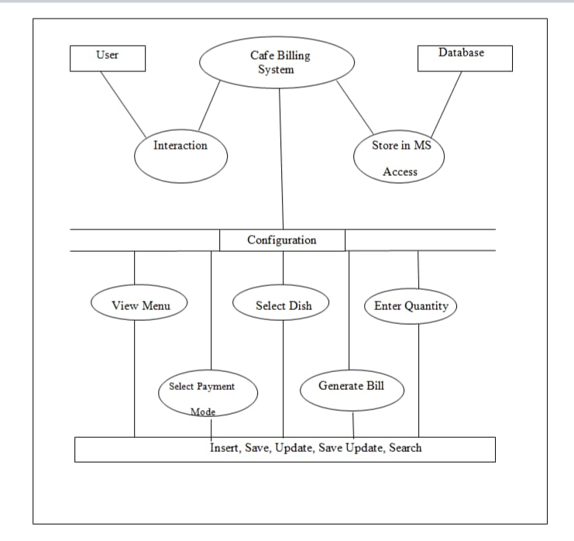

**3.2: EXPLANATION OF THE BLOCK DIAGRAM:**

This block diagram describes the working of Cafe Billing System. It is an connecting link between the user and database. User interacts woth the system and database stores information regarding the customer and its bill. It has some options which can be accessed i.e Menu, Bill Counter, Calculator. In the menu option the list of dishes with its cost will be displayed. In the bill count option there are many tabs will is used to select the dishes, enter quantity of that dish, selection of payment mode and then generation of bill. All this process consists of insertion, saving, updation, saving of updated information and searching.

**3.3: MODULES OF SYSTEM:**

**Registration:**

Users data need to be registered in the system so as to identify each of them uniquely and do the-the needed transaction as easy possible .like on the name of the bill will be issued. Beyond this, a lot of things are there where we can reference him.

**Select Item:**

Here we have the option to select the items we needed to get eat. On demand, we have options to search according to the various filter like the taste of food on the basis of rating, feedbacks, beverages, fast food, continental, state wise, healthy food, compliments etc.

Here onward one can select on the basis of filters according to price, newly added, special dish and much more us here. further, he can select as much as he can and added to his account in a very pleasant user interface.

**Bill:**

Now bill of the order will be prepared according to the items selected and further needs to shown to the user. Here tax calculation is also considered and then this is passed to total calculation and then bill according to the all is shown to the user and then payment part comes.

**Payment:**

Payment is selected by the customer either it is cash mode or by debit card or credit card as he demands the bill of the payment and order is collected by the customer after the successful payment and fed into the system.

**3.4: SYSTEM DESIGN:**

Now, this system is designed in such a way that it takes fewer resources to work properly. It has its own sort of minimum requirements that we need to take care of :

The system needs a minimum of 2 GB of ram to run all the features smooth and sudden.

It needs a minimum 1.3 GHz processor to rum smooth as less than that may create problems.

The system needs to be operated by some authorized person as wrong hands can make it irresponsible.

Rest is all up to the user’s usage will care for hardware

For security Antivirus is recommended.

The system has modules and classes to store every entity in a proper manner and needed to place in a proper manner so we need to have a proper design for that we put all of it in block diagram of this machine.

WIth this, every aspect of the system entities will be clear and gives a clear cut idea to code in sequence.

**3.4.1: Entity User:**

Every User detail needs to be stored in a proper manner with very needed attributed. So as it is very important with the view to monitor the particular customer’s likes and dislikes and further need to be given offers and gifts according to that to maintain the loyalty of the customers and retaining them for a long time.

In this world, the proper need of detail of the customer is required to deep analyze them accordingly. So we have the specific attributes of it as follows:

**3.4.2: Primary key User_id:**

The user id is system generated and unique, which can be referenced in any other entity.This mostly for recognizing it in the unique way anywhere in the program.

**3.4.3: Customer Name:**

Customer Name is taken from the customer and fed into this it is properly validated so that no mistake happens.

**3.4.4: Entity Items:**

Item is the dishes available for the customers to order for. Now, this should be dealt in such a way that we can manage it is very easy and quick manner no complexion should be there for the processed to filter it according to a particular attribute or according to category and price too.

For that reason, we need to make it clear with it attributes to reference.

**3.4.5: Dishes:**

Every food item is related some sort of category to make it more refined while searching in the interfaces and finding the precise choice and order quickly.

**3.4.6: Rate:**

Rate of every item is mentioned to make it accessible to calculate the bill and need to filter accordingly.

**3.4.7: Description:**

Some word is shed on it to describe the dishes according to popularity and few more data like most of the trending orders and much more which can attract customers to read it and order it when we fed this in a beautiful interface with the needed amount of shading and images.

**3.4.8: Entity Bill:**

Bill is calculated on the basis of items ordered and how many of individual items quantified. It has following attributes :

**3.4.9: Primary key Bill Number:**

This is system generated and is a unique one of the most useful attributes as we mandatory need this to reference it anywhere in the interfaces and clearly, show the data to user interfaces or admin reference.

**3.4.10: Quantity:**

A total number of items ordered are given here for every item the quantity is also mentioned.

**3.4.11: Total :**

The total price of every item which is a multiplication of the item number with price is mentioned here.

**3.4.12: Tax:**

As there are various taxes are levied on the dishes. Each kind is calculated and mentioned here.

**3.4.13: Sub Total:**

It is a total of all including taxes and another item total.

**3.4.14: Entity Payment:**

The payment entryway could also be provided by a bank to its customers, however, will be provided by a specialized money service supplier as a separate service, like a payment service supplier

A payment entryway facilitates a payment dealing by the transfer of data between a payment portal (such as a website, transportable or interactive voice response service) and therefore the forepart processor or exploit bank.

Many payment gateways additionally give tools to mechanically screen orders for fraud and calculate tax in real time before the authorization request being sent to the processor.

changes happened when developing this application, individuals don’t get to substitute long queue to deposit the instalments, no got to take a vacation for putting the repayments.

merely we are able to deposit our cash online through application wherever you discover totally different choices to pay the cash choices like, pay by open-end card or through UPI or Cash.

**Modes one can opt for is:**

**Card or UPI :**

This is the most common and most popular way payment. Due to advantages of need not to carry cash it gained popularity. Pos machines are handy in this case on customer part.

**Cash:**

If one does not have cards then he can always go for it but seems to become very old fashioned these days.

**CHAPTER 4: HARDWARE & SOFTWARE REQUIREMENTS**

**4.1: HARDWARE REQUIREMENTS:**

PIV 2.8 GHz Processor and Above

RAM 512MB and Above

HDD 20 GB Hard Disk Space and Above

**4.2: SOFTWARE REQUIREMENTS:**

WINDOWS OS (XP / 2000 / 200 Server / 2003 Server)

Visual Studio Code

Internet Information Server 5.0 (IIS)

Visual Studio Code (Minimal for Deployment)

Sqlite3

Python 3.9.2 64 bit

The **Database** used is Sqlite 3. We used Sqlite Database because it is easy to use and feasible for our project. The Types of database used - There are two types of database i.e. **Relational and Non relational database**. Relational consists of rows,columns and tables it means it is arranged in a sequential manner. Non relational consists of non tabular format which is not arranged in sequential manner. As our database stores data in rows, columns and tables it comes under relational database.

ID is the **Primary key** used. Our project does not have foreign key as it has only one table.

Foreign key- It is created by using Primary key.

As we have only one table of ID which is unique therefore we have only used primary key.

**The sql queries used in the code are:**

We have used CRUD(Create Read Update Delete) query.

**Below are the queries from code:**

SELECT COUNT(ID) FROM COMPANY;

CREATE TABLE IF NOT EXISTS COMPANY( ID INT PRIMARY KEY NOT NULL, NAME TEXT NOT NULL, BILL CHAR(9999) NOT NULL);

INSERT INTO COMPANY(ID,NAME,BILL) VALUES(?,?,?)

SELECT BILL FROM COMPANY WHERE ID=?

SELECT * FROM COMPANY

**4.3: FRONTEND AND BACKEND IN THE PROJECT:**

**Python - Frontend**

**Sqlite3 - Backend**

Python 3.9.2 is used in frontend and sqlite3 is used in backend.

Frontend- It is the GUI page which is displayed which consists of buttons, labels, etc.

Backend- It is the place where the data is stored.

So in our project we have created frontend using Python and Backend using Sqlite3.

**4.3.1: Advantages of Sqlite3:**

The most common and obvious use case for SQLite is serving as a conventional, table-oriented relational database. SQLite supports transactions and atomic behaviors, so a program crash or even a power outage won’t leave you with a corrupted database.

SQLite has features found in higher-end databases such as full-text indexing and support for JSON data. Application data typically stuffed into semi-structured formats like YAML or XML can be stored as SQLite tables, allowing the data to be accessed more easily and processed more quickly.

SQLite also provides a fast and powerful way to store configuration data for a program.

**4.3.2: Advantages of Python:**

1. Easy to Read, Learn and Write

2. Improved Productivity

3. Interpreted Language

4. Dynamically Typed

5. Free and Open-Source

6. Vast Libraries Support

7. Portability

**CHAPTER 5: IMPLEMENTATION**

**5.1: OVERVIEW OF RESULTS:**

First of all, the result shows home page of our Cafe Billing System. It consists of 6 buttons which are Bill Counter, Menu, Search Bill, Calculator, About Us and Exit. After this, on clicking Menu Button we can see the Menu Card which has food items divided into different categories based on their types. It displays a page which is used for selection of the dishes that are ordered. One can enter n number of quantities. Also it has buttons of Menu for viewing Menu , Calculator for Calculation of Bill , show receipt for viewing bill and print to print the bill. It also displays the customer information like customer name , bill number and asks customer for mode of payment. After confirming the order, it displays the bill along with taxes. Then after calculation of bill, it gives recipt of the bill. Also, we can search any customer’s bill on typing that respective bill number.

**5.2: CODE:**

**Home Page:**

class Front:

def _init_(self,window):

#===================Font===================

jls_extract_var = self

jls_extract_var.font1=("cinzel",50,"bold")

self.font2=("arial",24,"underline")

self.font3=("bell mt",105,"bold")

self.font4=("arial",18,"bold")

#================Top Frame=========

self.top=Frame(window,width=1366,height=120,bd=5,bg="#EEF5DB",relief=RAISED)

self.top.propagate(0)

self.top.place(x=0,y=0)

#===================Main label=============

self.l1=Label(self.top,text="CENTRAL PERK",font=self.font1,bg="#EEF5DB",bd=8,fg="#4B8BBE",justify=CENTER)

self.l1.place(x=235,y=0)

#=============Right Canvas==============

self.right=Canvas(window,width=1366,height=520,bd=5,bg="#4F6367",relief=RAISED)

self.image=ImageTk.PhotoImage(Image.open("2.jpg"))

id=self.right.create_image(680,250,image=self.image)

text=self.right.create_text(400,540,fill="#EEF5DB",font=("cinzel",27,"bold"),text="WELCOME TO CENTRAL PERK")

self.right.place(x=0,y=220)

#==================left Frame============

self.left=Frame(window,width=1366,height=100,bd=5,bg="#4F6367",relief=RAISED)

self.left.propagate(0)

self.left.place(x=0,y=120)

#=====================button=============

self.button1=Button(self.left,text="BILL COUNTER",width=15,height=3,bd=8,bg="#4F6367",

fg="#EEF5DB",command=self.call)

self.button1.place(x=450,y=10)

self.button2=Button(self.left,text="CALCULATOR",width=15,height=3,bd=8,bg="#4F6367"

fg="#EEF5DB",command=self.cal)

self.button2.place(x=900,y=10)

self.button3=Button(self.left,text="EXIT",width=15,height=3,bd=8,bg="#4F6367",

fg="#EEF5DB",command=self.exit)

self.button3.place(x=1200,y=10)

self.button4=Button(self.left,text="ABOUT US",width=15,height=3,bd=8,

bg="#4F6367",fg="#EEF5DB",command=self.aboutus)

self.button4.place(x=1050,y=10)

self.button5=Button(self.left,text="MENU",width=15,height=3,bd=8,bg="#4F6367",

fg="#EEF5DB",command=self.rate)

self.button5.place(x=600,y=10)

self.button6=Button(self.left,text="SEARCH BILL",width=15,height=3,bd=8,bg="#4F6367",

fg="#EEF5DB",command=self.sum)

self.button6.place(x=750,y=10)

#======================Calculator==============

def cal(self):

root=Tk()

obj=Calc(root)

root.title("calculator")

root.mainloop()

#===============================Exit Button===============

def exit(self):

window.destroy()

* This is the code for front page. Using this code we have designed the main frame of our Cafe Billing System which has six buttons i.e. Menu, Calculator, Bill Counter, Search Bill, About Us and Exit. All this buttons are designed using the above code.

**Receipt:**

self.bill=Frame(root,width=760,height=270,bd=5,bg="#4f6367",relief=RAISED)

self.bill.propagate(0)

self.bill.place(x=0,y=470)

#================Recipt=============

self.label1=Label(self.bill,text="SUB TOTAL=",font=self.font2,bg="#4F6367",fg="#EEF5DB")

self.label1.place(x=20,y=10)

self.sb=Entry(self.bill,bd=5,width=8)

self.sb.place(x=230,y=18)

self.sb.insert(END,int(0))

self.label2=Label(self.bill,text="TAX=",font=self.font2,bg="#4F6367",fg="#EEF5DB")

self.label2.place(x=330,y=10)

self.tax=Entry(self.bill,bd=5,width=8)

self.tax.place(x=420,y=18)

self.label3=Label(self.bill,text="TOTAL=",font=self.font2,bg="#4F6367",fg="#EEF5DB")

self.label3.place(x=520,y=10)

self.total=Entry(self.bill,bd=5,width=8)

self.total.place(x=660,y=18)

self.L1=Label(self.bill,text=" ",

font=("cooper",17,"italic"),bg="#4F6367",fg="#EEF5DB")

self.L1.place(x=10,y=140)

#==================button=========

self.button1=Button(self.bill,text="TOTAL",width=20,height=3,bd=6,bg="#4F6367",

fg="#EEF5DB",command=self.tot)

self.button1.place(x=20,y=70)

self.button2=Button(self.bill,text="SEARCH BILL",width=20,height=3,bd=6,bg="#4F6367",

fg="#EEF5DB",command=self.sum)

self.button2.place(x=200,y=70)

self.button3=Button(self.bill,text="SHOW RECIPT",width=20,height=3,bd=6,bg="#4F6367",

fg="#EEF5DB",command=self.insert)

self.button3.place(x=390,y=70)

self.button4=Button(self.bill,text="PRINT",width=20,height=3,bd=6,bg="#4F6367",

fg="#EEF5DB",command=self.prt)

self.button4.place(x=580,y=70)

#======================================================

#==========================recipt======================

#======================================================

self.recipt=Frame(root,width=600,height=400,bd=20,bg="#4F6367",relief=RAISED)

self.recipt.propagate()

self.recipt.place(x=760,y=340)

self.ric=Text(self.recipt,width=42,height=12,font=("arial",18,"bold"),relief=RAISED)

self.ric.place(x=2,y=5)

self.ric.insert(END,str("DESCRIPTION QTY RATE AMOUNT"))

self.scrollbar=Scrollbar(self.recipt)

self.scrollbar.place(x=532,y=270)

self.scrollbar.configure(command=self.ric.yview)

self.ric.configure(yscrollcommand=self.scrollbar.set)

* This code is for generating Receipt. It displays bill with the dishes ordered along with the quantity and rate and also it displays the total with taxes included.

**Customer Details:**

self.left=Frame(root,width=490,height=220,bd=5,bg="#4F6367",relief=RAISED)

self.left.place(x=870,y=120)

#=====================label====================

self.labelcd=Label(self.left,text="CUSTOMER INFORMATION",bg="#4F6367",

font=self.font2,fg="#EEF5DB")

self.labelcd.place(x=0,y=20)

self.labelcn=Label(self.left,text="CUSTOMER NAME:-",bg="#4F6367",

font=self.font4,fg="#EEF5DB")

self.labelcn.place(x=0,y=80)

self.labelcm=Label(self.left,text="BILL NUMBER:-",bg="#4F6367",

font=self.font4,fg="#EEF5DB")

self.labelcm.place(x=0,y=120)

self.labelpm=Label(self.left,text="PAYMENT METHOD:-",bg="#4F6367",

font=self.font4,fg="#EEF5DB")

self.labelpm.place(x=0,y=160)

#==================Entry Box==================

self.entry1=Entry(self.left,width=25,bd=3)

self.entry1.place(x=260,y=85)

self.entry2=Entry(self.left,width=25,bd=3)

self.entry2.place(x=260,y=125)

#===============dropdown menu===============

self.ddvar=StringVar()

self.method={"By Cash","By Card","By UPI"}

self.ddvar.set("By cash")

self.dropdowm=OptionMenu(self.left,self.ddvar,*self.method)

self.dropdowm.place(x=260,y=165)

* The above code is for saving Customer's Information. We can save Customer's Name, Mode of Payment so that if in future we want to check our previohs customer's records we can easily view it

**5.3: EXPLANATION OF CODE:**

This project Cafe Billing System gives us the facility to manage the Cafe's billing system. This application is helpful for billing of food ordered and managing customers details. This application maintains the records related to Customers information, paynent details, etc.

We can enter the details of new food items and retrieve the details of food items available in the System. We can generate the bills for the customers. We can also maintain the records of customers. In this project we can maintain the GST calculation of every food item. GST can be issued according to specified categories of all the food items.

**CHAPTER 6: RESULTS AND DISCUSSION**

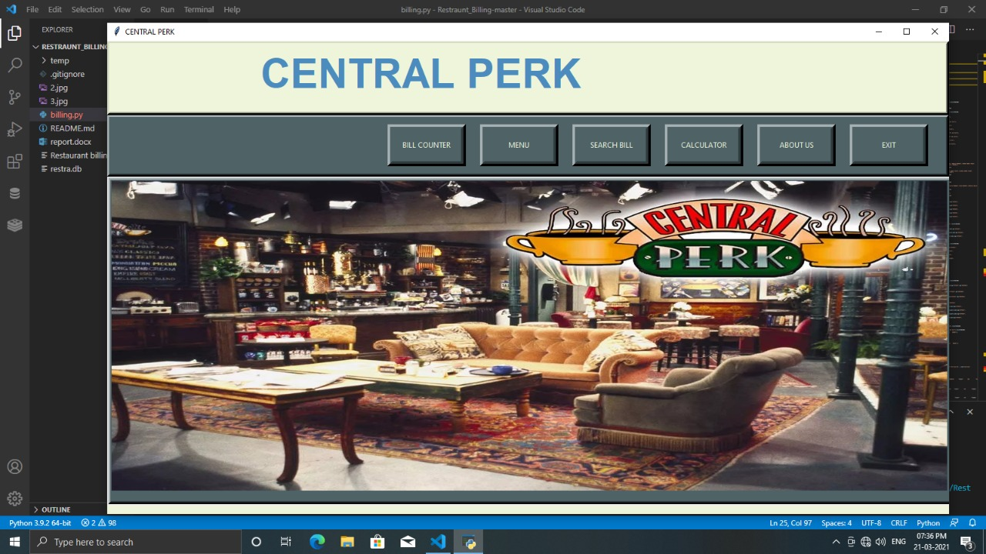This application is helpful for staff or admin for billing of food order and managing customers details. This application is accessed by only staff and admin. This application maintains the records related to Customers, etc. We can generate the bills for the customers. This is shown in the figures below.

**Figure 6.1: Home Page**

This figure shows the home page of our Cafe Billing System. It consists of 6 buttons which are Bill Counter, Menu, Search Bill, Calculator, About Us and Exit.

* Bill Counter: It displays the calculated bill of the customer along with taxes.
* Menu: It displays the Menu Card for ordering.
* Search Bill: It searches the bill of the particular customer.
* Calculator: It is used for calculation purpose.
* About Us: This gives a short information about the Cafe.
* Exit: This is used to close the System.

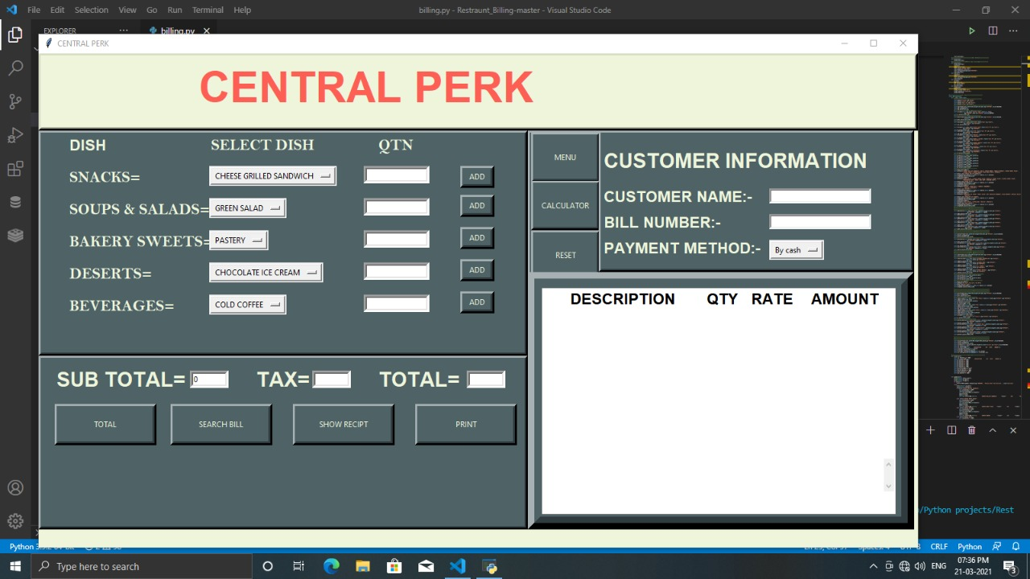

**Figure 6.2: Order Details**

* In the figure this page is used for ordering the dishes. One can enter n number of quantities.
* Also it has buttons of Menu for viewing Menu , Calculator for Calculation of Bill , show receipt for viewing bill and print to print the bill.
* It also displays the customer information like customer name , bill number and asks customer for mode of payment.

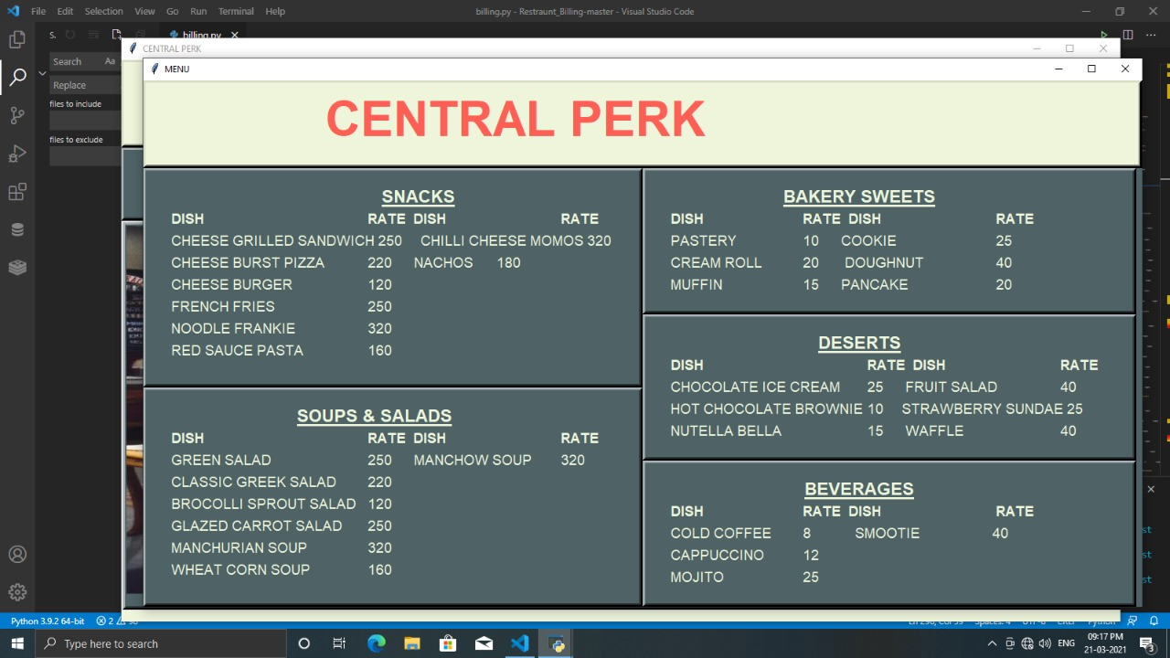

**Figure 6.3: Menu Card**

This figure displays menu card for ordering purpose. All the dishes are segregated in different food categories according to their types. Dishes have their rates against them.

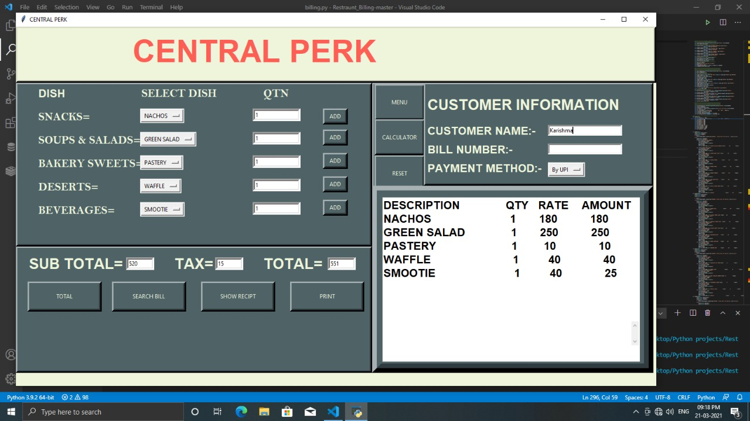

**Figure 6.4: Post Order Details**

This is how the screen will appear after adding quantities and calculating the total along with description of the order. It also shows the Customer’s name, payment mode of the order and it’s bill number.

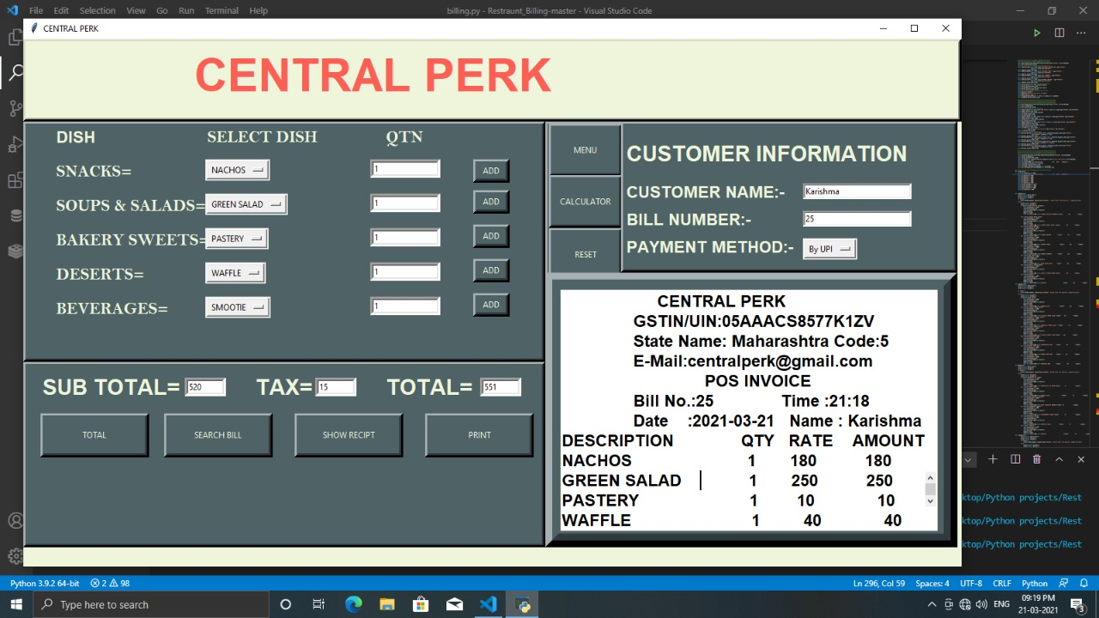

**Figure 6.5: Bill**

This figure displays the bill along with the taxes and the Customer Information.

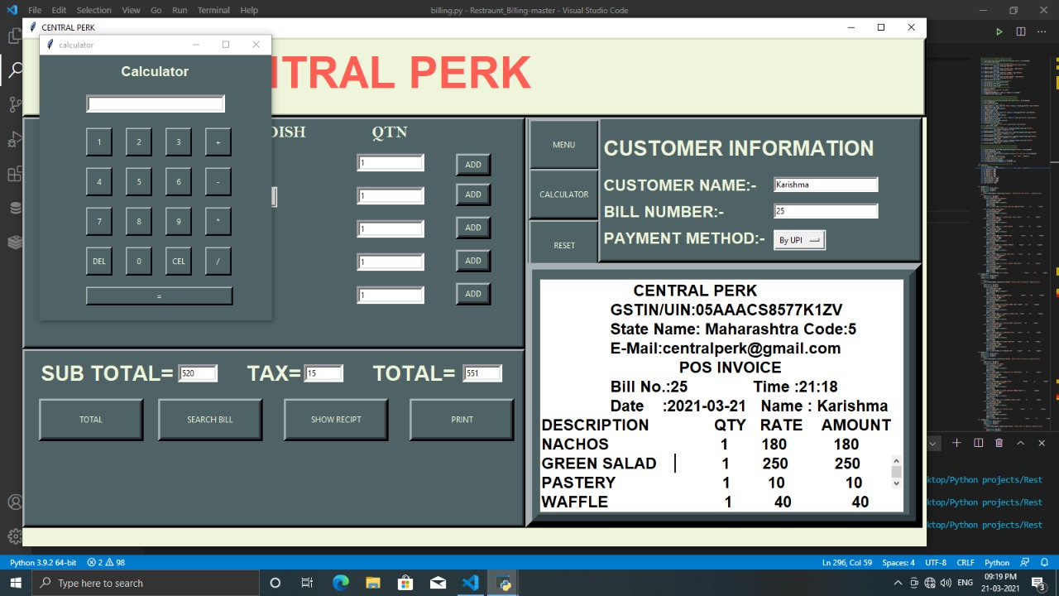

**Figure 6.6: Calculating Order Bill**

In this figure one can see that the calculator button proves beneficial for the cashier to calculate error free payments. Hence, the bill of the order is calculated.

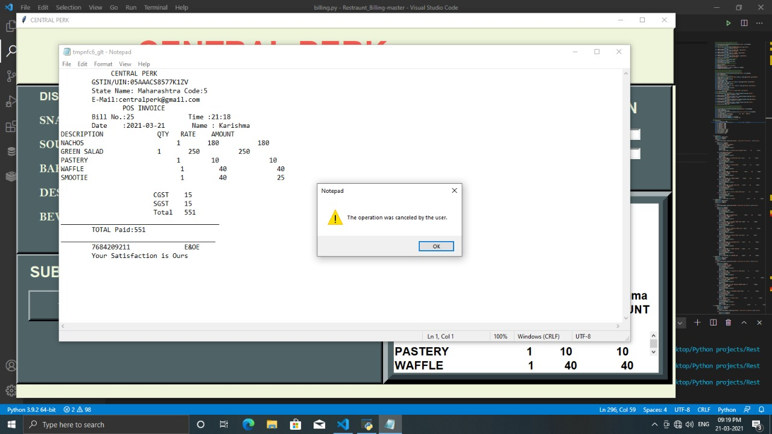

**Figure 6.7: Receipt of the Bill**

This figure shows the printing of bill. Customers receive the bill after their order.

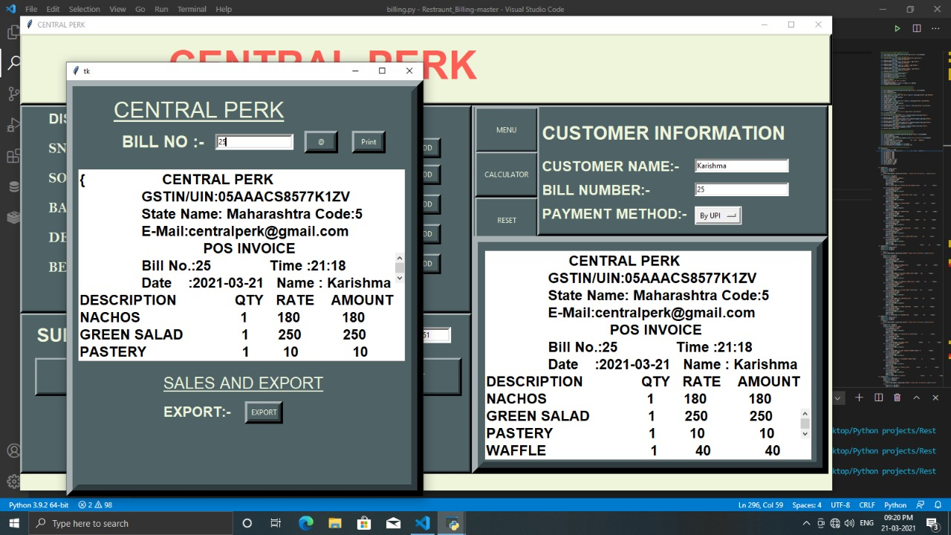

**Figure 6.8: Searching Bill of previous customer’s**

This figure shows Search Bill button which is used to search previous customers bill with all the saved information. Hence, we can keep track of all the orders.

**CHAPTER 7: CONCLUSION**

After we have completed the project we are sure the problems in the existing system world overcome. The "Cafe Billing System" process made computerized to reduce human errors & to increase the efficiency. The main focus of this project is to less human efforts and to get the correct information about a customer visit in the Cafe. The maintenance of the records is made efficient, as all the records are stored in the Access Database, through which data can be retrieved easily. The navigation control is provided in all the forms to navigate through the large amount of records. If the numbers of records are very large then user has to just type in the search string & user gets the results immediately. The editing is also made simple. The user has to just type in the required field & process the update button to update the desired field.

* The customers are given a particular unique id no. so that they can be accessed correctly & without errors.
* The system will be simply utilized by the staffs of various departments and is powered with extremely customisable strong options to fulfill each demand of our customers.
* It generates unique transaction id for billing according to the selection of the mode of payment.

**REFERENCES**

1. <http://eprints.utar.edu.my/3448/1/fyp_IA_2019_WSJ_1506513.pdf>
2. <http://www.iaetsdjaras.org/gallery/14-jaras-327-december.pdf>
3. <https://www.ijser.org/researchpaper/A-Review-Paper-on-Smart-Restaurant-Ordering-System.pdf>
4. <https://www.irjet.net/archives/V7/i4/IRJET-V7I41009.pdf>
5. <https://sites.google.com/site/ignoubcafinalyearprojects/project-report/billing-system-project-report>
6. <https://www.iosrjournals.org/iosr-jeee/Papers/Vol10-issue3/Version-1/A010310105.pdf>